API Automation Pack

Axway Part 2

September 14, 2020

Joseph Joy

**Purpose:**

The purpose is to create an API Testing Automation framework where the logs are captured in the notepad and the Test Results are updated in the Test Data sheet.

**Tool Used:** SOAPUI

SoapUI is a tool for testing Web Services. These can be the SOAP Web Services as well RESTful Web Services or HTTP based services. SoapUI is an Open Source and completely free tool with a commercial companion -SoapUI Pro- that has extra functionality for companies with mission critical Web Services.

SoapUI is java based, so it runs on most operating systems, SoapUI requires a 1.6+ version of the JRE (Java Runtime Environment), at least 1 GB of memory is recommended, and about 100 MB of disk space.

**Methodology:**

Step 1: Place the jar mentioned below in the bin-> ext folder of SOAPUI.

* fillo-1.18.jar
* jxl-2.6.12.1.jar



Step 2: Unzip the pack which is shared below. It contains two folders namely:

* DATABASE: The Test Data sheet is placed here. The cases with value “1” in the Execute Column will be executed.
* PACK: The folder where you can find the .xml file



Step 3: After importing the .xml file. You can trigger the test cases. The cases with value “1” in the Execute column of Testdata sheet will be executed.

Step 4: Once the Execution is completed you can open the Testdata sheet where you can find the test results updated along with the path for the logs. (Pls. refer the screenshot given below)

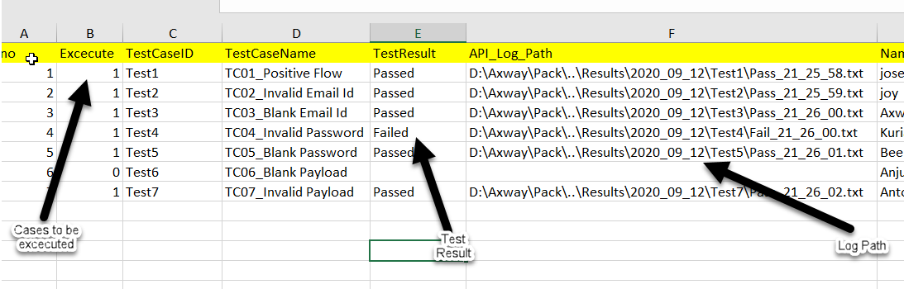

Screenshot 1 – Test Data sheet